**Recipe Cove**

**User Stories and Mockups Booklet**

*(Laboratory of Advanced Programming 2022/2023)*

Valerio Di Stefano (1898728)

Giuseppe Prisco (1895709)

In this booklet we summarize all the user stories that have been identified for our system and we present a first draft for the user interface of the application in the form of LoFi Mockups.

Aside from the obvious registration and login processes, we identified a range of user stories which were relevant to the goals of our final system’s vision: they range from the search for recipes and their information to the creation of in-app artifacts, such as Calendars, reminders and a favorite list.

In the following pages, for each Html page represented by a Mockup, we specify which user stories are met for each functionality to be implemented in the final system.

At the end of the document we also included a storyboard which clearly presents the connections between the pages and the user stories involved.

**Home Page**

From the Home page, the user has the ability to register/login to our system, he can use a Chat-BOT microservice to search recipes following a particular diet, or search them directly through the use of a search bar.

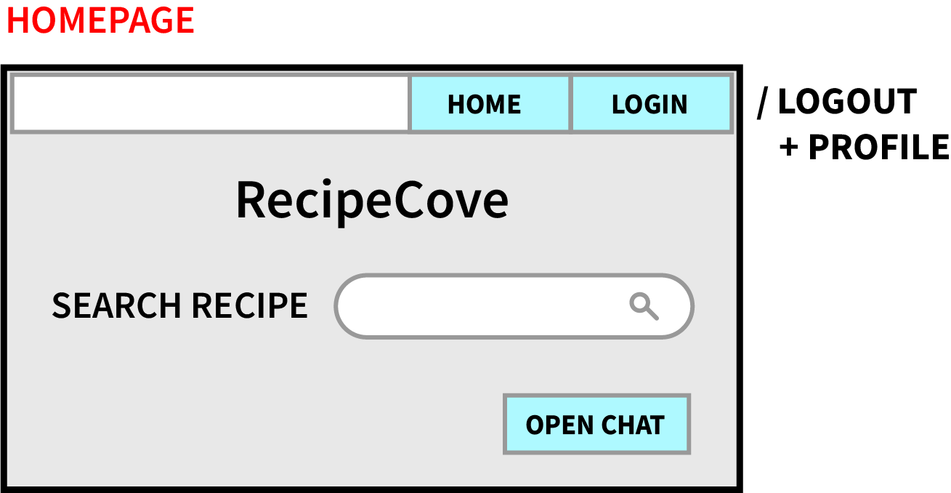

1. As a visitor, I want to be able to register in the website with an external account, so that I can use an existing Google account
2. As a visitor, I want to be able to search a recipe by its name, so that I can search only what interests me
3. As a visitor, I want to be able to check the suggested recipes for a specific diet, so that I can be inspired in what to prepare each day
4. As a registered user, I want to be able to perform the login, so that I can access other system's functionalities
5. As a registered user, I want to be able to perform the logout, so that I can leave my information within the website
6. As a registered user, I want to be able to access my profile page, so that I can check my personal information

**Search Results Page**

From the search results page, it is possible to see all the results in accordance to the search terms inserted and it is possible to click on each result to be prompted to the Recipe Page, which contains all the relevant information of the selected recipe.

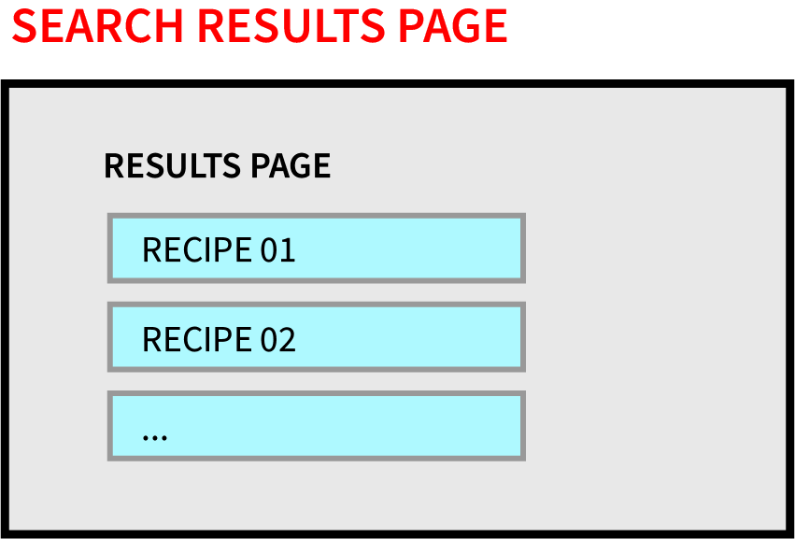

1. As a visitor, I want to be able to search a recipe by its name, so that I can search only what interests me
2. As a visitor, I want to be able to see the information of a recipe, so that I can learn more about it

**Recipe Page**

In the Recipe Page it is possible to check all of its information, including its ingredients, as well as put it in the user’s favorite list and create reminders for the user’s calendar.

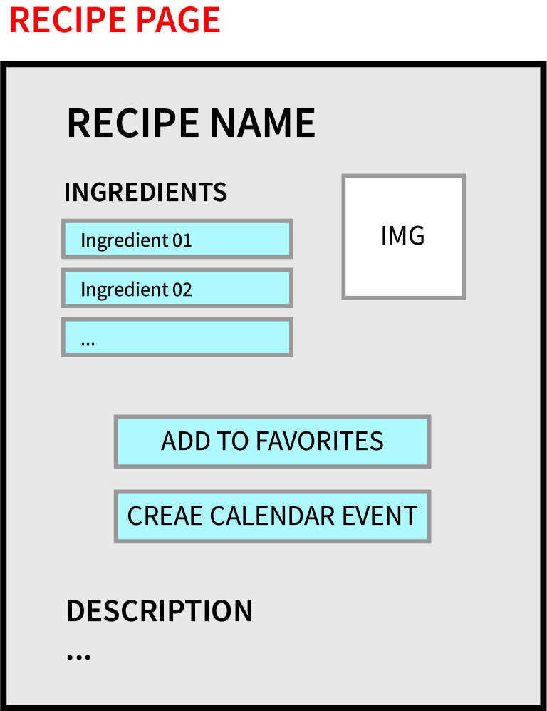

1. As a visitor, I want to be able to see the information of a recipe, so that I can learn more about it
2. As a visitor, I want to be able to see the information of an ingredient, so that I can know the details of each ingredient in a recipe
3. As a registered user, I want to be able to add an event to my Calendar, so that I can be reminded on a specific day to prepare a particular recipe
4. As a registered user, I want to be able to add a recipe to my favorite list, so that I can keep track of all the recipes I like

**Ingredient Page**

The purpose of the ingredient page is to visualize the most relevant information about the ingredients used in a particular recipe, ranging from the percentage of proteins, fats and carbs, to the nutritional values of the ingredient.

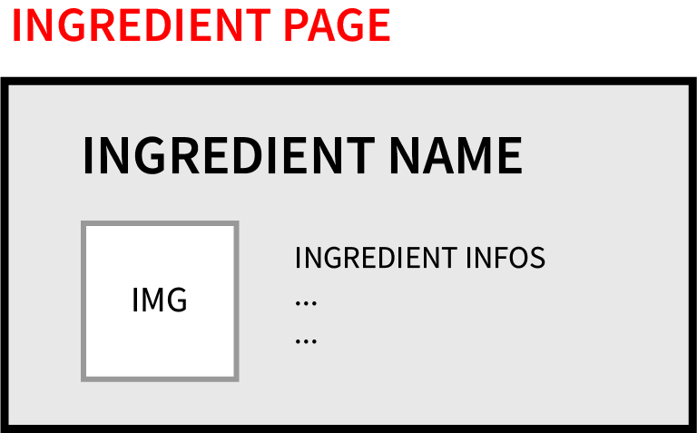

1. As a visitor, I want to be able to see the information of an ingredient, so that I can know the details of each ingredient in a recipe

**User Profile Page**

This page gathers the information of the registered user, including his account info, favorite recipes list and personal calendar. From this page it is possible to create or delete a calendar, and to remove specific recipes from the favorite list. The user can additionally delete his account.

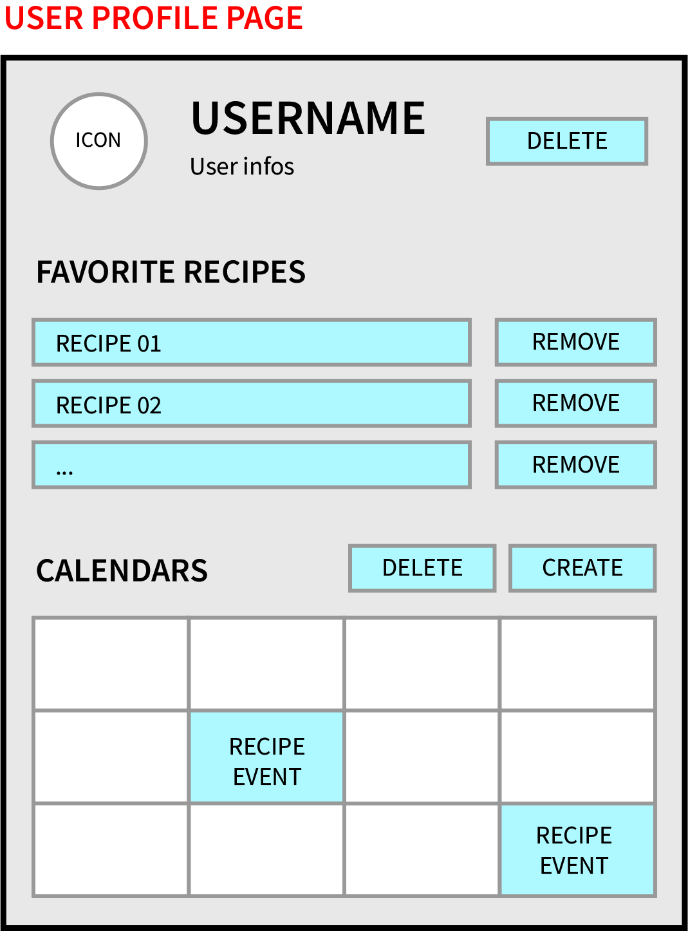

1. As a registered user, I want to be able to access my profile page, so that I can check my personal information
2. As a registered user, I want to be able to create a Calendar, so that I can populate it with events relating recipes
3. As a registered user, I want to be able to delete a Calendar, so that I can remove the data gathered within the website
4. As a registered user, I want to be able to remove a recipe from my favorite list, so that I can stop being interested in it
5. As a registered user, I want to be able to see my favorite list, so that I can check my current interests in recipes

**Recipe Calendar Event**

This page is used to allow the user to fill in all the details that he wants to include in a new event for his calendar. The information to fill should include the description of the reminder, the start and end dates as well as the displayed color palette for the event.

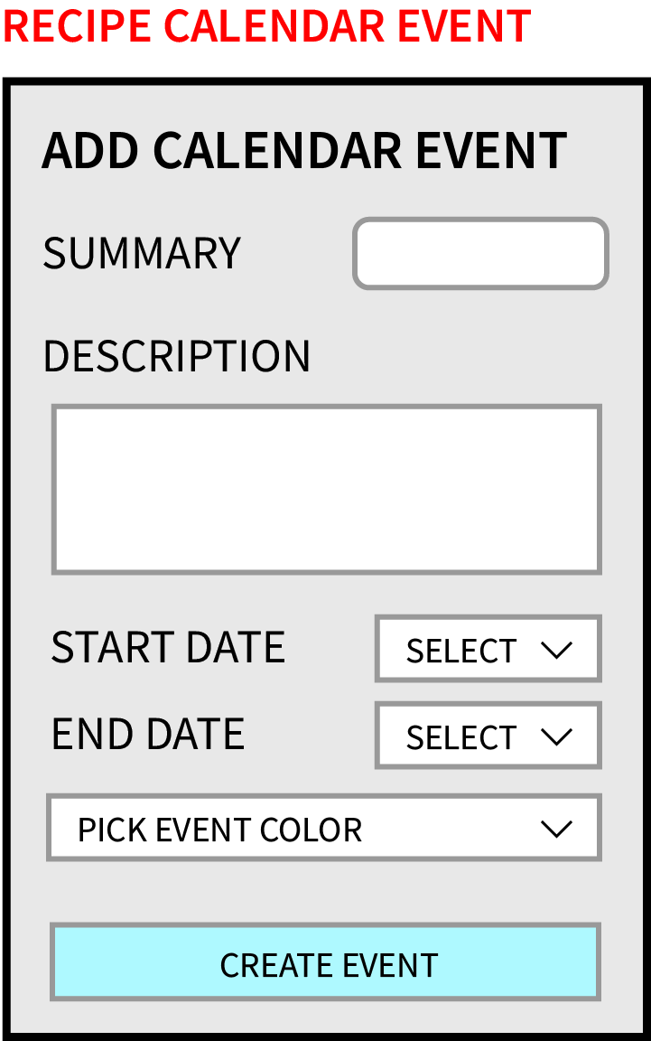

1. As a registered user, I want to be able to add an event to my Calendar, so that I can be reminded on a specific day to prepare a particular recipe

**Chat-BOT (Menu)**

Instead of being a standalone page, the Chat-BOT functionality should be presented to the user as an overlay Menu, placed at the bottom of the Home Page. This Menu should suggest a recipe based on the user's diet interests.

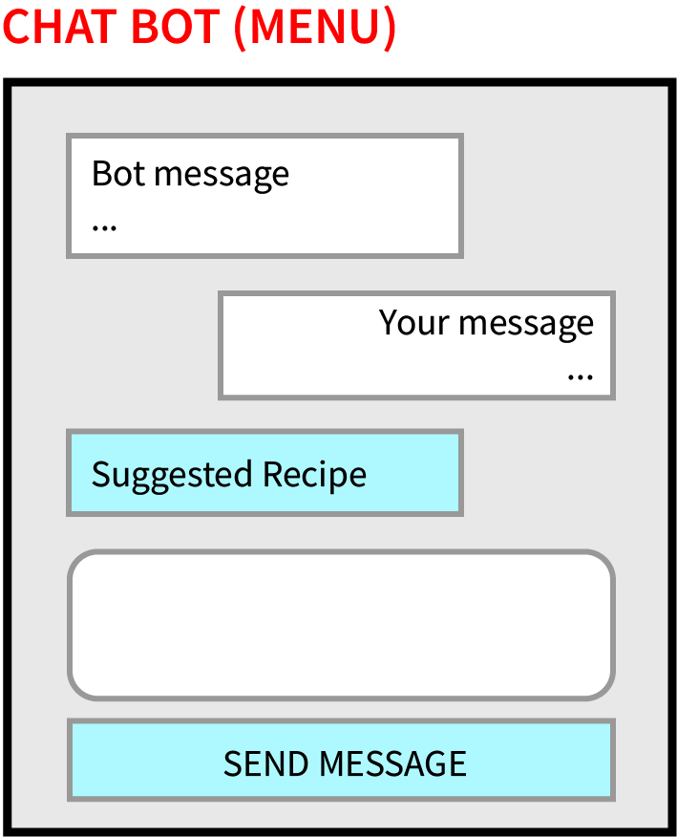

1. As a visitor, I want to be able to check the suggested recipes for a specific diet, so that I can be inspired in what to prepare each day

**Storyboard**

In this section we present the storyboard, which includes all the Mockups and user stories. It should allow the reader to clearly follow the interactions with the links and buttons of the system, while also keeping in mind which user stories are involved in each interaction.

